***CAD UPGRADE-- Tuesday June 12th from 7am-1pm.***

***A-Shift into B-Shift***

***What you need to know:***

1. MDC’s will be working. We will however have everyone restart their MDC at the end of the upgrade and accept the required updates.
   1. When directed by Dispatch units will need to logoff, restart, and then, accept updates.
   2. During the time MDC’s are down, all status will be by radio.
2. Station Alerting will be working.
3. Paging through CAD and Active 911 will be offline.
4. RMS and Zoll will be offline. Incidents will be pushed to these interfaces when the upgrade is completed.
5. ** Non-Ops Divisions can complete the upgrade steps below after 1145am and are not required to monitor the radio.

***What you need to do:***

***9 am***

1. Have 1 radio monitor FTAC 201/202. Dispatch will broadcast CAD UPGRADE INFO on these channels
   1. City--FTAC 201
   2. County--FTAC 202

***If you have questions you can reach Dispatch on these channels.***

1. Power off the MDC *when directed by Dispatch.*
2. Power on your MDC *when directed by Dispatch* and accept updates. This can take 30-45 seconds. When all updates have been accepted you will see Version 5.807.62(see below).

*\*\*Mobile updates can only be downloaded at the station from a Wireless Access Point.*

1. After you have accepted the updates, logon your personnel.

*\*\* Remember to update all apparatus in your station. Brush Trucks, Reserve Units, Command Vehicles, etc.*

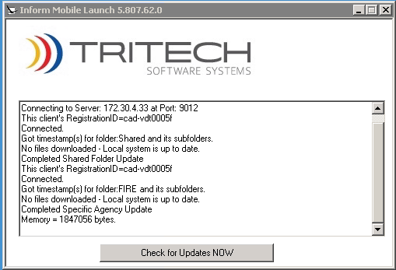

1. The upgrade process is completed when the MDC displays the version listed above and you have logged on. Units can discontinue monitoring the radio and return to normal operations.