CAD UPGRADE INSTRUCTIONS
Monday March 13th from 7am-1pm. --A-Shift into B-Shift at Noon.

What you need to know.
- Paging through CAD and Active 911 will be offline.
- RMS and Zoll will be offline. Incidents will be pushed to these interfaces when the upgrade is completed.

MDC’s will be working.
Station Alerting will be working.

What you need to do.

730am

- Have 1 radio monitor FTAC 201/202. Dispatch will broadcast CAD UPGRADE INFO on these channels
  - City--FTAC 201
  - County--FTAC 202
If you have questions you can reach Dispatch on these channels.

MDC INSTRUCTIONS--ONLY WHEN DIRECTED BY DISPATCH

Logout/Power Down
- Select Logout from the MDC menu and Logout your unit

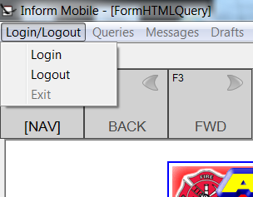

- Push the “MDC ONLY” button, then the “X” in the upper Right Corner to close the screen
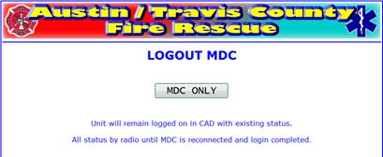

- Click the icon like this and then select RESTART
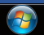

LOGIN--ONLY WHEN DIRECTED BY DISPATCH

- Use the “Update Now” button to accept updates.
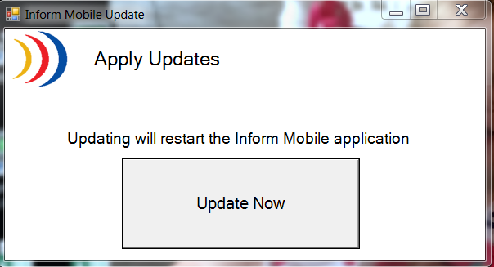

- Press the “Check for Updates NOW” button and verify you have VERSION 5.734.38.0 on the top of this box.
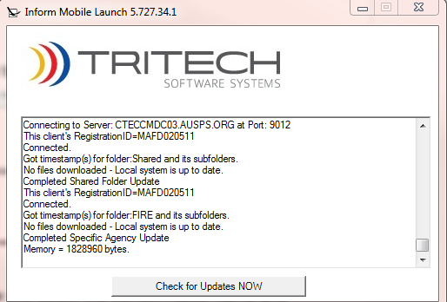

- Login your unit. Make sure you select the correct Radio Name and Vehicle #.

