**CAFCA Wildland Firefighting**

**Extended Attack Class**

**July 10th, 2013**

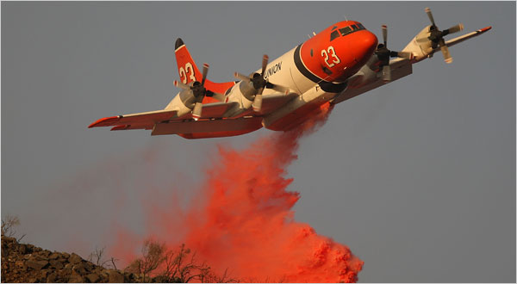

Hosted by the Austin Fire Department

Instructor: Assistant Director Jim Linardos

Course Cost: Free

This course is designed to teach the information that command level Fire Officers and Wildfire Managers “Need to Know”. Topics include all aspects of large wildfire management including: Air operations, Tactics, Resource ordering, Accountability, and Risk Assessment, to name a few.

The Course to be held at the Austin Fire Department Regional Training Center at 4800 Shaw Lane in building J, classroom 3. Start time will be at **0830** hrs.

Limited to 30 seats

Reserve your spot by emailing Captain Randy Denzer at [douglas.denzer@austintexas.gov](mailto:douglas.denzer@austintexas.gov)